Submission overview checklist

Your Name: Jadon Kosberg
Date: 11/4/2025

Instructions:
Copy Pseudocode Exercise 1: Compute miles per gallon here:
Start
Prompt user to enter milesDriven
Prompt user to enter gallonsUsed
Calculate milesPerGallon = milesDriven/gallonsUsed
Display milesPerGallon
End
Copy Lucidchart Exercise 1: Compute miles per gallon here:
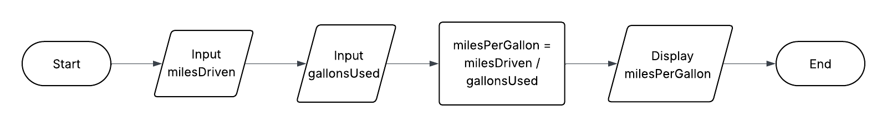

Copy Pseudocode Exercise 2: Compute daily rent costs here:
Start
Prompt the user to enter totalRent
Prompt user to enter numberofDays
Calculate dailyRent = totalRent / numberofDays
Display dailyRent
End
Copy Lucidchart Exercise 2: Compute daily rent costs here:
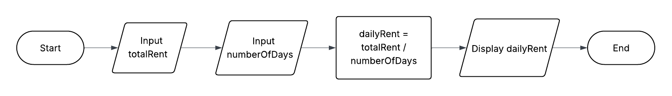

Copy Pseudocode Exercise 3: Think about a routine task or decision-making process in your daily life here:
Start
Display "Making Breakfast"

Get ingredients
Get cooking tools

Toast Bread
Fry eggs
Pour juice into a glass

Put food on a plate
Sit down at a table
Eat breakfast
End
Copy Lucidchart Exercise 3: Think about a routine task or decision-making process in your daily life here:

